School-Based Programs Quarterly Report Narrative

The Center for Youth

Report Period: September 1, 2021-February 28, 2022

Director of School-Based Programs: Paul Clark

Director of Restorative Practices and Equity: Nolica Murray-Fields

Associate Director of School-Based Programs: Eric Eagan

Assistant Director of School-Based Programs: Faith Davignon-Roy

Assistant Director of School Based Programs: Kia Brooks

Assistant Director of Prevention Education Services: Colin Wilcox

Programs

Social/emotional support services-help zone/ats
- The program has successfully been implemented and staffed at schools 2, 3, 4, 5, 8, 10, 12, 16, 17, 19, 28, 33, 34, 42, 45, 50, 58, East, Edison, Franklin, Northeast, Northwest, Monroe, Renaissance, Urban Choice Charter School, Wayland Cohocton, Hilton, Greece, Mt. Morris, Livonia, NorthStar. LynxC

New Sites for 21-22 School Year
Arkport
York
Pavilion
Geneseo
All Hilton Schools
Additional staff at Wayland Cohocton
School #7 RCSD
The LYNXC Program RCSD
NorthStar

School Year RCSD
Total visits: 15,950
Unique youth: 3,086

School Year Greece
Total visits: 5,016
Unique youth: 805

School Year Hilton
Total visits: 2,875
Unique youth: 489

School Year Rural/SouthTowns
Total visits: 6,437
Unique youth: 1.034

TOTAL visits: 30,278

TOTAL unique youth: 5,414

Average visits per youth: 5.59

GRADE
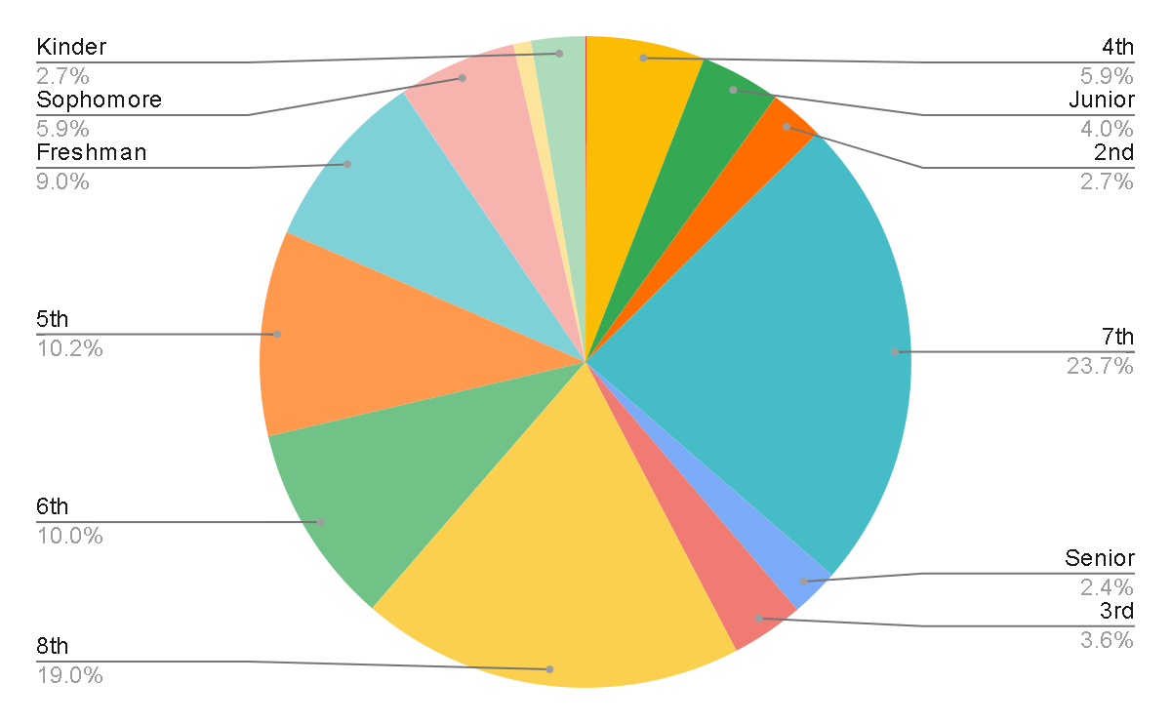

AGE
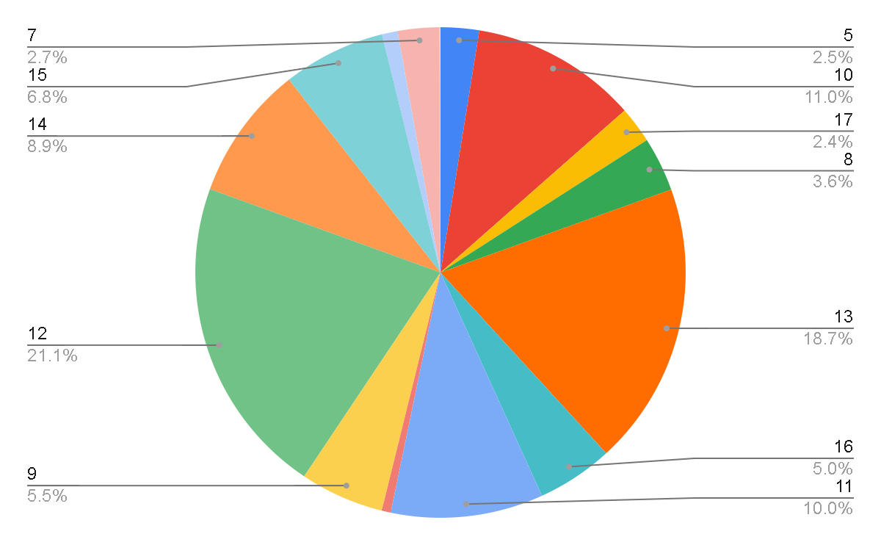

GENDER
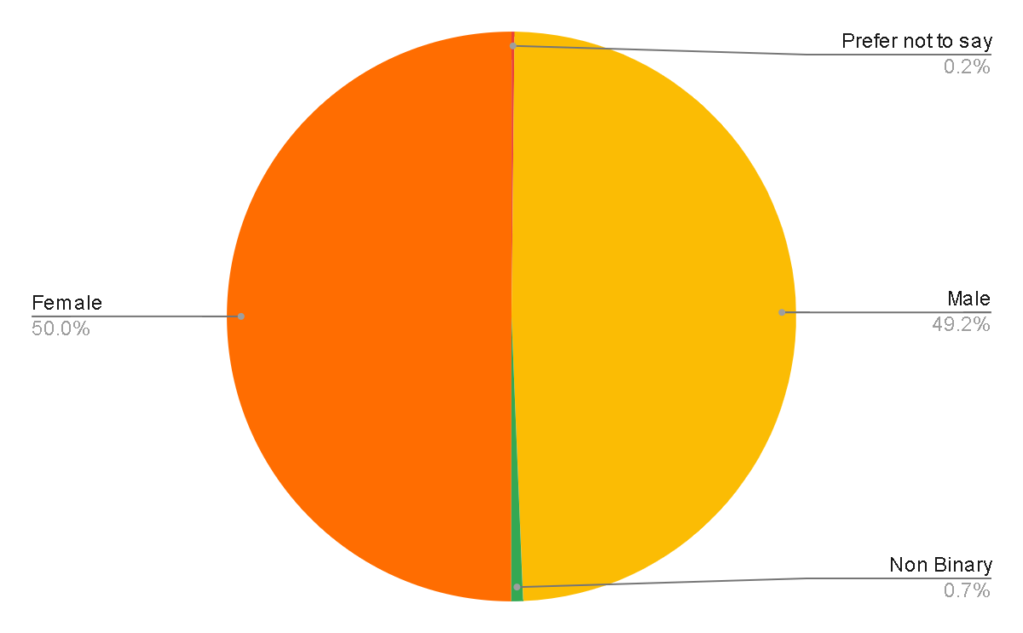

RACE
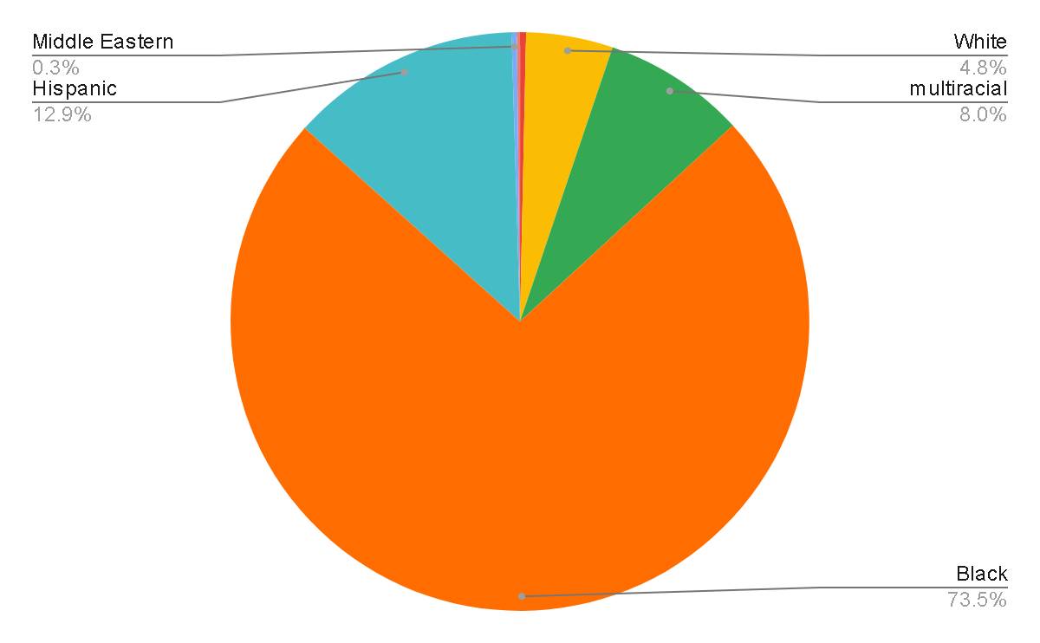
REFERRAL SOURCE
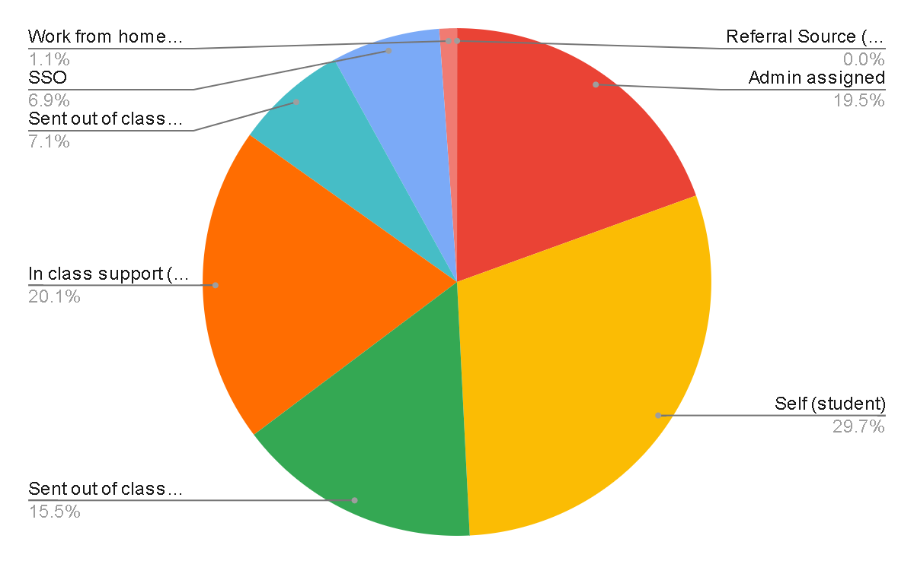

LOCATION STUDENT CAME FROM
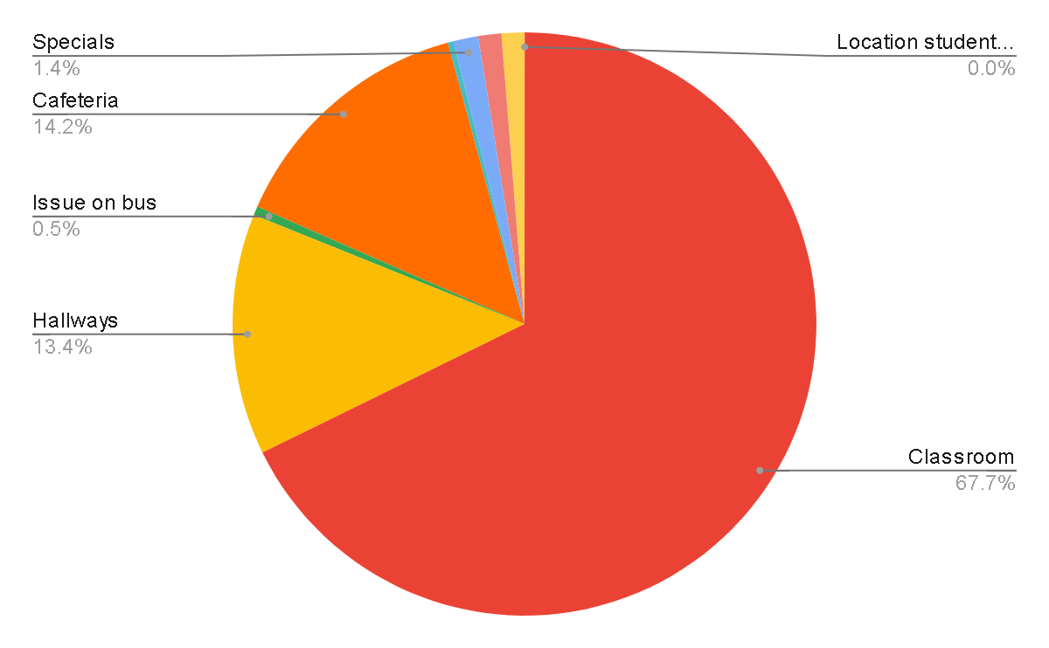

INTERVENTION
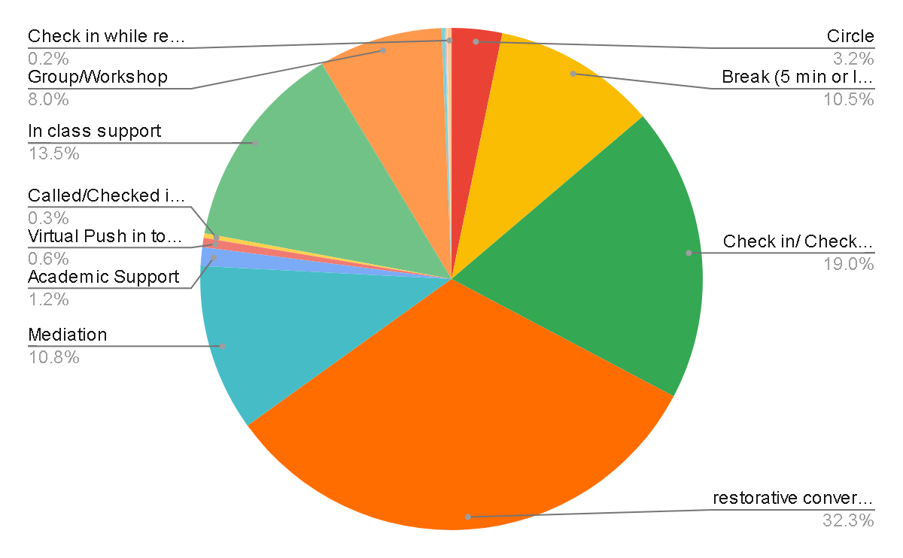
21st cc: School #45

I. Major Activities and Accomplishments
This quarter:

The 2020-2021 school year has been a challenging year for both our students and our staff. However, we did not allow the pandemic to stop us from fulfilling the needs of not just our students but our community as a whole. This school year, we have been able to face whatever challenges came our way in supporting both our students and their families.

During the second semester CFY staff were back in the building and began to be more hands on with our students both in the classroom and with those students whom were still via Zoom. Staff are working one-on-one with students, social emotionally and academically. CFY staff are making daily phone calls for attendance and setting goals with those students whom are having truancy issues, as well as coming up with incentives to help them achieve those goals. Home visits are being made as well on a as needed basis. We offer both workshops and social emotional activities during Kindergarten through 3rd grade lunch periods. Workshops and social emotional activities are offered on an as needed basis for students in grades 4 through 8th.

Community Schools / Mary McLeod Bethune School No. 45

Community Schools operate as a special hub of integrated social services and programs providing equity and access to underserved students by harnessing the resources of local partners to improve student outcomes and strengthen our community. It is a strategy that could enhance our youth and change the mindset of all community stakeholders, while incorporating the development triangle which includes, Core Instructional Programming, Expanded Learning Opportunities and Comprehensive Support Services.

Each community school is a reflection of local needs, assets, and priorities, no two look exactly alike. What they do share, however, is a commitment to partnership and to rethinking - and at times rebuilding - relationships based on a strong foundation of trust and respect. School No. 45 fully embraces this motto using a goal driven approach while monitoring student academic progress.

What makes community schools unique is the combination of four key pillars (Integrated Student Supports, Expanded and Enriched Learning Time and Opportunities, Active Family and Community Engagement, Collaborative Leadership and Practices) that together create the conditions necessary for students to thrive.

Our main partner is The Center for Youth that provides a continuum of high-quality services which focuses on the social-emotional well-being of our students and families. At our site we have dedicated Child and Family Therapists, Crisis/Prevention Intervention Specialist, Family Support Specialist, a Community School Coordinator and a Site Director who infuse the community motto into our day-to-day practices. We also oversee a community food pantry and clothing closet that is accessible to all.

Since we here at Mary McLeod Bethune Community School No.45 have committed to adopting this motto, we have been able to both identify family and community barriers and have shown significant improvement academically and socially. This all contributes to our ultimate goal of community sustainability.

Deliverables:
1. Food Cupboard
2. Drive-Thru Parent Breakfast
3. Clothing Closet
4. Property beautification
School-BASED Counseling

I. Major Activities and Accomplishments
This quarter:
- 25 referrals received for service;
- 20 open cases;
- 62 crisis interventions; and
- 12 peer mediations facilitated.
- 3 Teen Intervene
- 3 Newsletters

II. Problems/Obstacles
- Covid restrictions within School setting.
- High quantities of students in need of community mental health services continues and limited access to in person services
- Students declining Teen Intervene and Individual counseling services.

III. Significant Findings and Events
- Weekly classroom push ins
- East High weekly Academic reports

IV. Dissemination And Other Activities
- Final Newsletters

The Center for youth afterschool program

This quarter:
I. Major Activities and Accomplishments
During phase 2 and 3 of the RCSD school re-opening plan, only a limited number of students returned and that was with hybrid model limitations. Consequently, it proved to be close to impossible to offer an Afterschool on the School 45 premises. With our Center for Youth recently-acquired building, located at 797 Monroe Ave, we began offering individual sessions in mid-April, 2021 (with first preference given to all School 45 students). The sessions are as follows:

LEARN 2 EARN

I. Major Activities and Accomplishments

Current Learn 2 Earn Services
- Alternative Secondary School Services or Drop-out Recovery Services
- Paid and Unpaid Work Experiences
- Occupational Skills Training
- Education Offered Concurrently with and in the same context as Workforce Preparation
- Leadership Development
- Supportive Services
- Adult Mentoring
- Follow-Up Services
- Comprehensive Guidance & Counseling
- Financial Literacy Education
- Entrepreneurial Skills Training
- Labor Market and Employment Information Services: Career Awareness, Counseling, and Exploration
- Preparation for Postsecondary Education and Training
Numbers

Enrolled in PY21-22: 85 Youth - One additional only waiting on social security card in mail, five more clients only have one last enrollment appt left.
Currently Active: 60 Youth
Currently in Follow Up Services: 28 Youth

Problems & Obstacles
- Significant staff turnover
- Clients have become comfortable not taking the bus for the past year and are struggling to make it via public transportation to appointments
  - some have become really comfortable with unemployment offering enough income for them to Lyft/Uber around town and then they don't want to come in until they get paid again so they can use Lyft/Uber
- Clients have been receiving unemployment which has allowed them to stay home with their children and they prefer that over working or going to school (respectfully so!)
- A lot of mental health/substance abuse problems that are preventing youth from engaging in education & employment
- Lower referral numbers due to so many agencies being remote and not working as closely with clients to investigate needs.

The Following Reports will be submitted by 3/4/22.
1. EarthWorks
2. The Center for Youth After School Program at School 45
3. Prevention Education Services

